**Resolving Merge Conflict**

1. Verify if master is in clean state

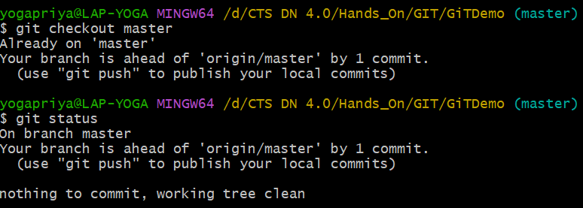

1. Create branch GitWork and add hello.xml

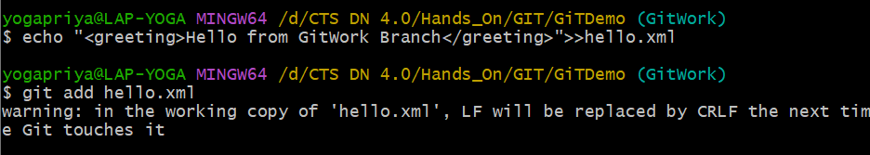

1. Update content of hello.xml and observe status



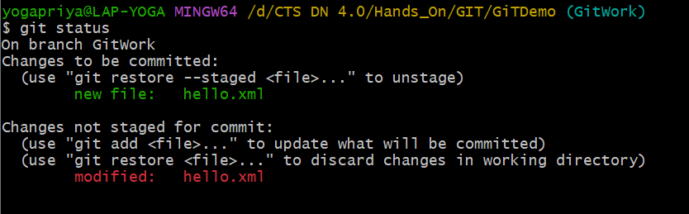

1. Commit changes to branch

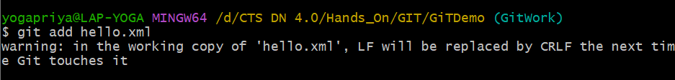

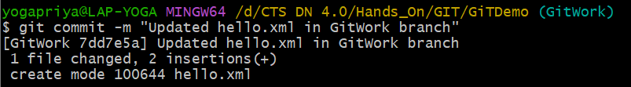

1. Switch to main



1. Add hello.xml in main with different content

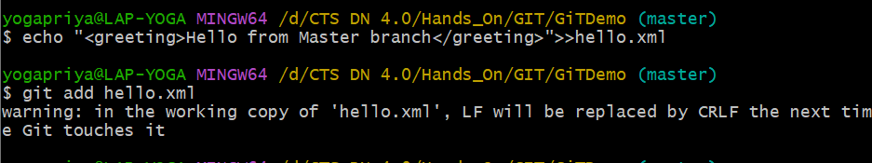

1. Commit changes to main

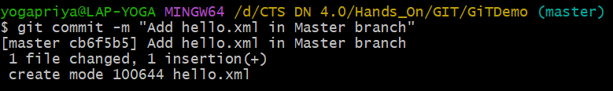

1. Observe log

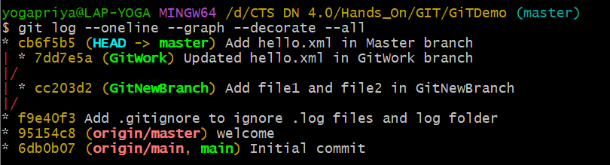

1. Check differences with gitdiff tool

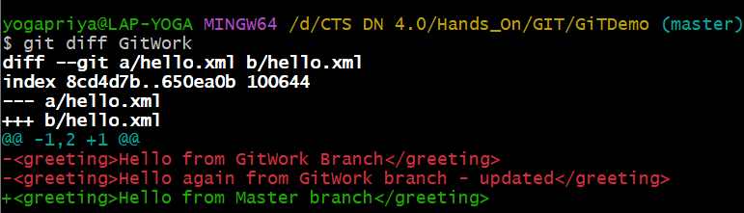

1. Use P4Merge for better visualization

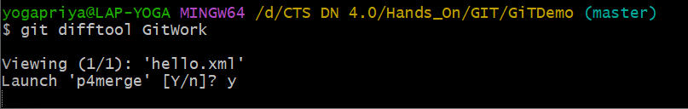

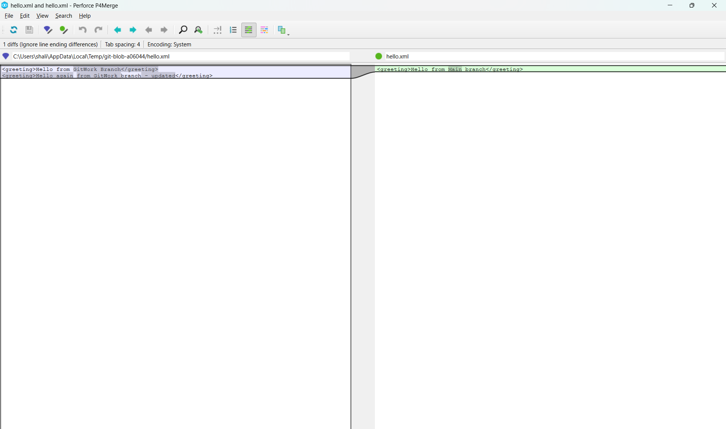

1. Merge branch into master

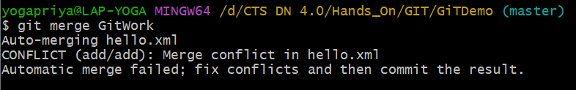

1. Observe the git mark-up

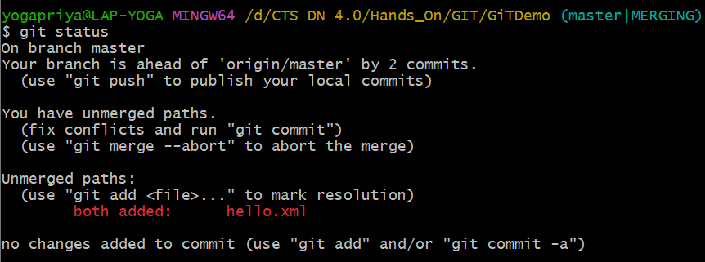

1. Use 3-way merge tool to resolve conflict

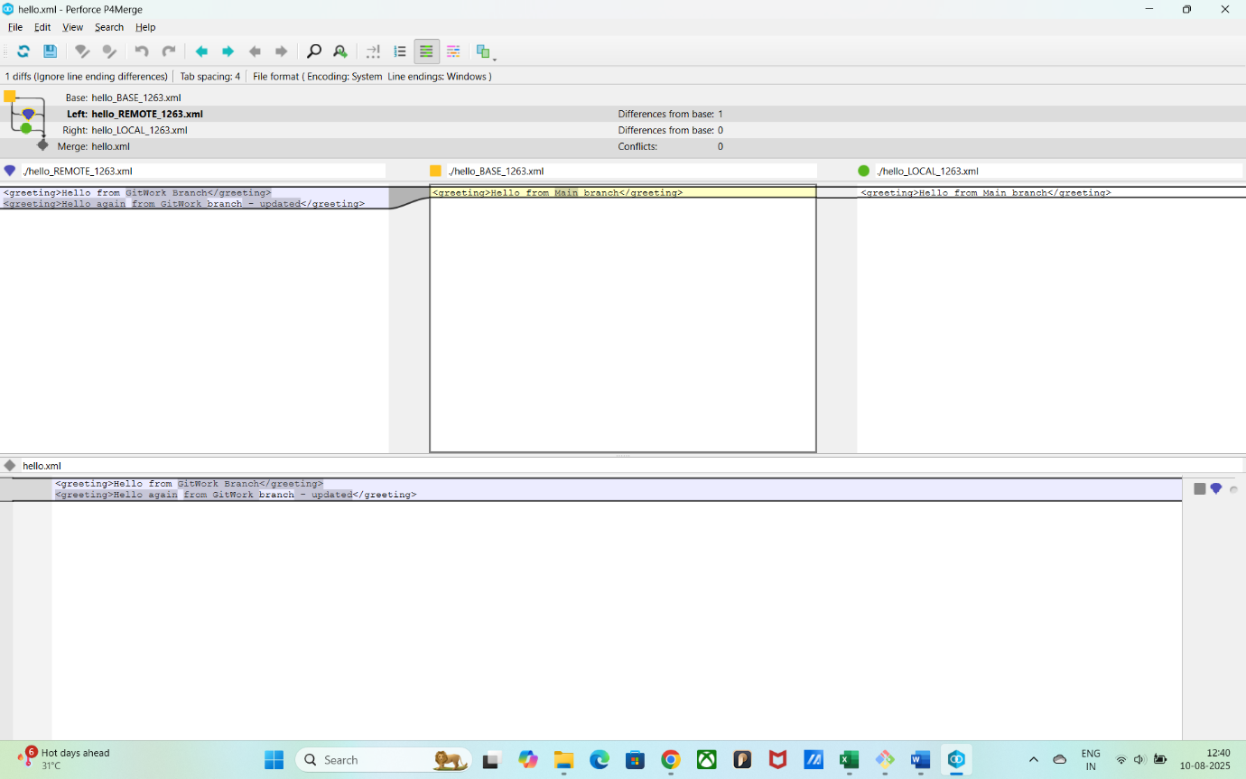

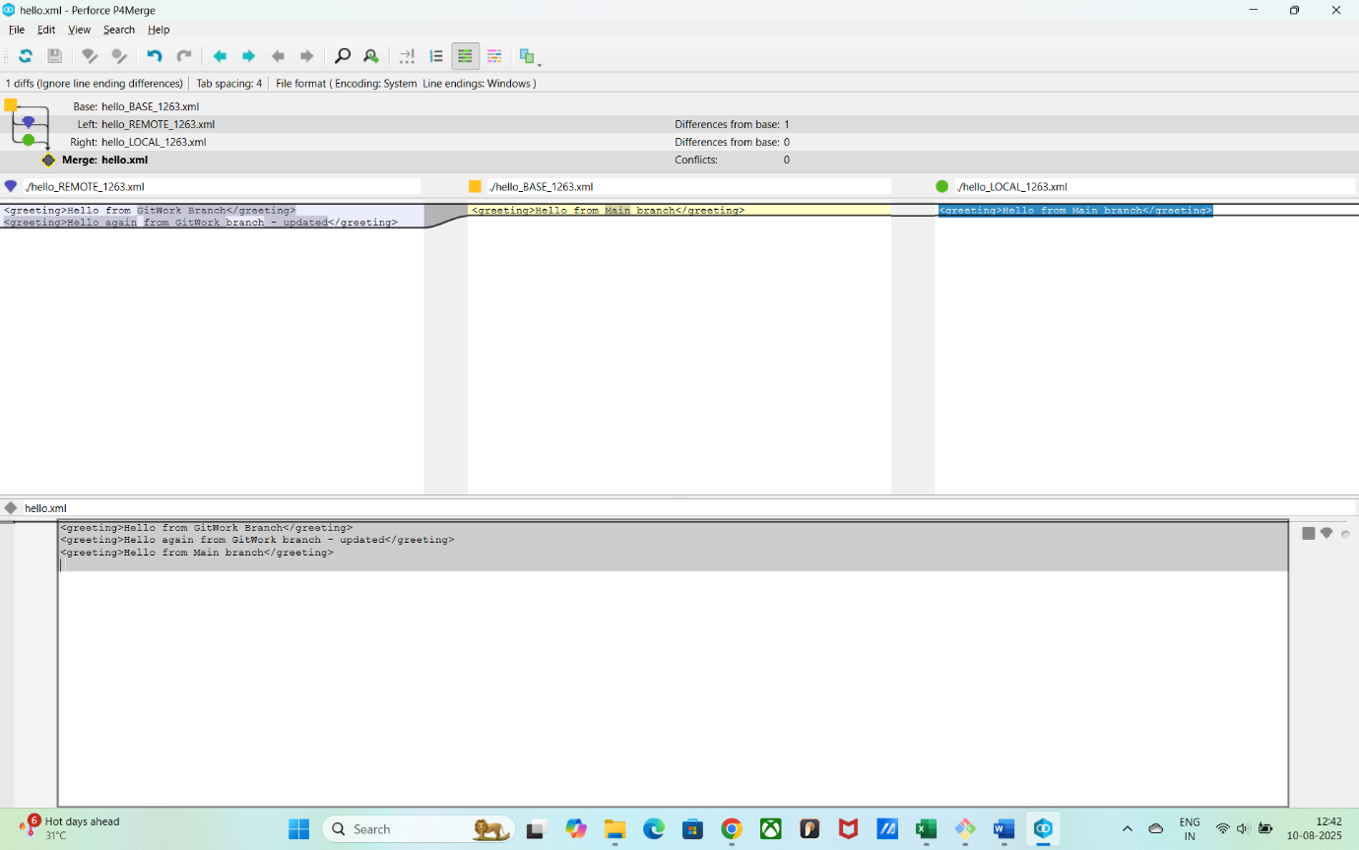

1. Commit after conflict resolution



1. Observe git status & add backup file to .gitignore

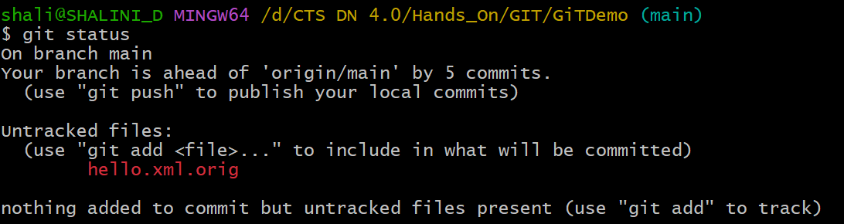

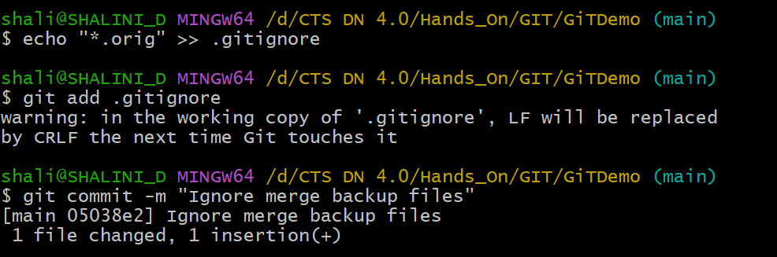

1. List all available branches

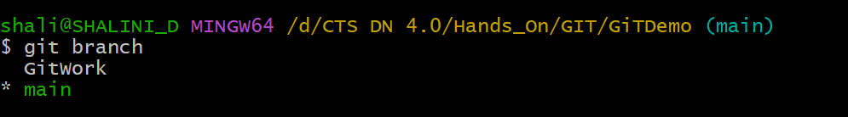

1. Delete merged branch

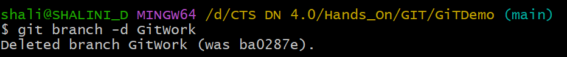

1. Observe final log

